Public Accounts Committee
Employment and support allowance inquiry

NAWRA Response

May 2018

NAWRA: Secretary - Kelly Smith C/O CPAG, 30 Micawber Street, London N1 7TB Tel: 02078125232 email: Kelly@nawra.org.uk
web: www.nawra.org.uk
The National Association of Welfare Rights Advisers
- The National Association of Welfare Rights Advisers (NAWRA) was established in 1992 and represents advisers from local authorities, the voluntary sector, trade unions, solicitors, and other organisations who provide legal advice on social security and tax credits. NAWRA currently has more than 200 member organisations.

- We strive to challenge, influence and improve welfare rights policy and legislation, as well as identifying and sharing good practice amongst our members.

- NAWRA holds four conferences throughout the year across the UK, attended by members from all sectors of the industry. An integral part of these events are workshops that help to develop and lead good practice.

- Our members have much experience in providing both front line legal advice on benefits and in providing training and information as well as policy support and development. As such NAWRA is able to bring much knowledge and insight to this consultation exercise.

- NAWRA is happy to be contacted to provide clarification on anything contained within this document. NAWRA is happy for details and contents of this response to be made public.

Executive summary
- This response is informed by a survey of NAWRA members carried out in the first week of May 2018 and the rightsnet discussion forum thread. Rightsnet is a social welfare law website that is used by thousands of advisers across the UK every day. The discussion thread on the subject of migration from incapacity benefit to employment and support allowance has been active since February 2014 and, at the time of writing, has had 307 replies and 116,215 views – the longest discussion thread in the entire forum.
- The DWP has maintained that, although admitting it was at fault in not assessing claimants for income-related employment and support allowance (irESA) at the point of migration, any backdating should be limited to 21 October 2014 on the basis that the decision in LH v SSWP [205] AACR 14 interpreted the relevant legislation and is regarded as a ‘test case’.

- Key findings include –

- Welfare rights advisers have been contacting the DWP about the failure to assess claimants for irESA on migration from incapacity benefit since 2011 in individual cases;
- A letter was sent to Caxton House in July 2014 alerting the DWP officially at national level to the fact that this was a systemic problem;
- In the majority of cases, up to some point in 2017, backdated irESA was paid to the point of migration – sometimes this was resolved easily, but sometimes it took a lot of perseverance and escalation;
- DWP internal guidance in June 2013, and in the Decision Maker’s Guide from before February 2014, clearly sets out that on migration a claimant should be assessed for both contributory ESA and irESA;
- The DWP were fully aware of the correct way to carry out the assessment on migration well before the decision in LH v SSWP and, up until 2017, were revising incorrect decisions on the basis of official error and awarding full backdating.

Survey response
- NAWRA received 65 responses to the survey, which was only open for a week due to the short time scale. A summary of the responses is set out below.

- Response to question ‘When did you first start dealing with cases where irESA was missing?’
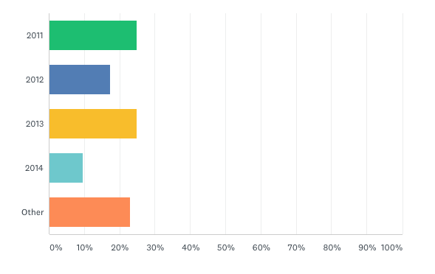

- Response to question ‘Did you have to escalate the cases to get resolution?’

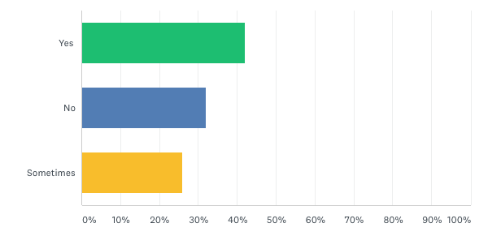

- Response to question ‘If you escalated, how did you go about this?’

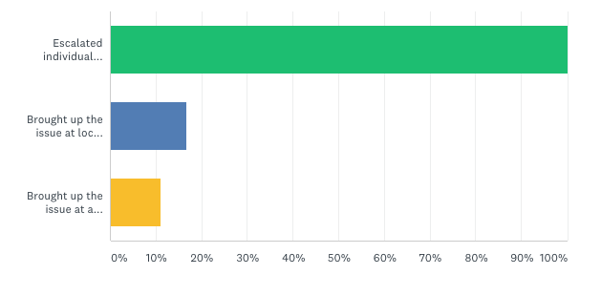
Note: Green – escalated individual cases; Blue – brought up the issue at local liaison; Yellow – brought up the issue at a higher level
- Response to question ‘How far back have you been successful in getting backdating generally?’
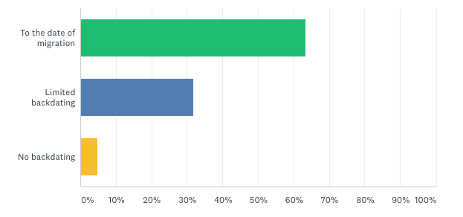
- The graphs above indicate that cases of irESA not being assessed on migration were first identified by welfare rights advisers as early as 2011. Sometimes the cases were resolved quite easily, sometimes they required escalation. The majority of cases have been backdated fully. Below are some typical case studies from just one adviser –

- Client AF - migrated to ESA 18/10/2012, ESA3 (form collecting income details in order to assess irESA) sent with adviser cover letter pointing out arrears missing - submitted 18/11/15, arrears issued back to date of migration in February 2016.

- Client AH, migrated to ESA 09/03/2013, ESA3 sent with adviser cover letter pointing out arrears missing - submitted 29/01/2016, arrears issued back to 27/07/2013 in August 2017. No arrears right back to date of migration due to client not being entitled to severe disability premium at that point and other contributory benefits making client overscale.

- Client WS - migrated to ESA 12/09/12, ESA3 sent with adviser cover letter pointing out arrears missing - submitted 05/08/16, arrears issued back to date of migration in November 2016.

- Client LM - migrated to ESA 11/12/2012, ESA3 sent with adviser cover letter pointing out arrears missing - submitted 24/01/2017, arrears issued back to date of migration in August 2017.

- 2 cases at Oldham (DWP centre dealing with trawl of affected claimants) awaiting decision; NC who migrated to ESA on 21/04/2012 and MH who migrated to ESA 25/06/2014.

- 1 case at mandatory reconsideration stage as arrears issued back to 2014 when the date of migration was 22/05/2013, awaiting mandatory reconsideration notice.

Timeline of rightsnet discussion thread

- The following is a summary of the key points of the rightsnet discussion thread which can be viewed in full at https://www.rightsnet.org.uk/forums/viewthread/5928 - the relevant post numbers are highlighted for easy reference. This thread provides evidence of welfare rights advisers’ experiences and actions as it happened from February 2014.

- The first posting (by Andrew Dutton) to the thread was on 6 February 2014 when he noticed that too many cases were cropping up where claimants had not been assessed for irESA on migration from incapacity benefit (IB) –

‘This scenario keeps cropping up:
- claimant was on IB without IS top-up
-migrated to ESA and placed in Support Group
- receives ESA decision which includes what appears to be an IRESA assessment
-this assessment tells them that their CESA level is, for instance, £112.05 - this includes a ‘top-up’ (transitional amount)
- it also states that their applicable amount for IRESA is £106.50 (£71.70+34.80)
- therefore they cannot get IRESA
-the assessment does not include Enhanced Disability Premium
-some do not include Severe Disability Premium where client is on relevant DLA etc
-claimant is locked in to this situation as they will not know, without advice, that anything is amiss
We have dealt with individual cases, lodged appeals, made complaints – but it seems as if there are more than just a few of these cases about, and that there may be many people (nationwide?) who have been underpaid or not paid IRESA because premiums have been missed.
As far as I can see, JC+ should be checking cases like these for possible entitlement to IRESA but it would appear at least in some cases that something’s going wrong.
Is anyone else finding this?’
- Post 3 references the Decision Maker’s Guide and quotes directly from it – paragraph 45414 states –
‘This enables the Secretary of State to establish whether a claimant whose existing award is IB or SDA [severe disablement allowance], and who is not entitled to IS [income support], might be entitled to ESA(IR) as well as ESA(Cont) on conversion.
Example
Carlton is entitled to IB of £91.40. During the conversion phase the Secretary of State establishes that he has no other income. Following application of the WCA [work capability assessment], Carlton is placed in the support group. On conversion, Carlton is entitled to ESA of £110.50 made up of ESA(Cont) of £96.85 and ESA(IR) of £13.65 (EDP).’

- Posts 5 to 8 (all posted the same day as the original post) confirm that similar errors are being found elsewhere in England, and in Scotland and Wales.

- At post 9 Mr Dutton suggests that a national caseload trawl is necessary and at post 22 he follows this up with a letter to DWP at Caxton House (a copy of the letter is at the end of the report – please note that the date on the letter says 3/7/13 but it should say 3/7/14 as that is when it was sent as confirmed in the thread) – the letter sets out how the award letters to claimants are confusing and that the DWP is not following its own guidance by failing to assess for irESA.

- At post 30 Mr Dutton advises that he has received a reply (after a prompt) from the DWP Ministerial Correspondence section ending with ‘I have ensured that the team responsible has been made aware of your comments which they will take into account on their next review’. It is worth noting that this letter pre-dates the decision in LH v SSWP.

- At post 33 another adviser – Rosie W - advises that she had attended an appeal which lapsed prior to the hearing as the presenting officer gave her a copy of DWP internal guidance (attached to the post), dated 5 June 2013, which confirms –

‘Where a claimant was previously entitled to IB, the DM [decision maker] should therefore consider whether they are entitled to ESA(IR) as well as (C) on conversion even if they were not entitled to IS [income support]. If this is not done at conversion, and the claimant would have been entitled to ESA(IR) at that date, the conversion decision should be revised for official error.

The guidance in DMG Chapter 45 will be expanded as soon as possible to make this clearer.’

- At post 35, pending an Upper Tribunal hearing, DWP paid out full arrears – 27 months worth – to the estate of a claimant who had sadly recently died.

- At post 41 Mr Dutton remarks that he is still awaiting a reply from the Director General to his July 2014 letter, and then at post 43 (29 January 2015) he receives a reply saying the stakeholder group is going to look at the letters.

- At post 44 it is highlighted that a lot of these cases are coming to the attention of advisers as claimants are getting fines and penalties from the NHS Business Services Authority due to not paying prescription/dental charges as they believed they were getting irESA. On investigating the charges the DWP error comes to light.

- At post 50 a Freedom of Information response dated 7 May 2015 from the DWP states –
‘In assessing benefit entitlement the Department firstly considers whether a person entitled to IB or SDA is eligible for contributory ESA and then whether a transitional addition is needed to maintain a claimant’s benefit income. Secondly for those entitled to Income Support consideration is given to eligibility for income-related ESA and again whether a transitional addition is payable to maintain benefit income.
When it is known that IB or SDA recipients have limited capability for work DWP attempts to phone them to give general advice about income-related entitlement so that they can request an application form. Advice about income-related ESA is also given in the written notification when a claimant’s entitlement is converted to ESA. Depending on the response of claimants they are sent an application form and asked to provide the information necessary to determine income-related entitlement.’
- At posts 61 and 62, in June 2016, more examples of cases giving full backdating are given – the DWP is still accepting that official error has been made.

- At post 63, in June 2016, the issue is raised with the stakeholders’ group again as the problem has not been resolved.

- At post 73, in August 2016, a reply is received from the stakeholders’ group stating –

‘I have now spoken with colleagues working on the Health and Work Portfolio who have advised that Work has been undertaken to ensure claimants have the correct premiums awarded at the correct time.
As the last claims to be affected have already started the journey, it is late in the process to issue guidance. However if there is any particular area/ district that seems to be standing out as at fault or even a couple of examples can be provided we can investigate and issue a direct reminder to Benefit Centres as appropriate.
If you are able to provide these details they will be passed on to colleagues to investigate.’

At this point the DWP appears to be saying that it no longer believes the issue to be a problem.

- At post 82, in March 2017, fully backdated cases are still happening and arrears are high – in excess of £17,000 in the case quoted.

- At post 93 NAWRA has written a letter to the then Secretary of State Damian Green (dated 31 March 2017) making reference to the discussion thread and requesting a trawl to identify all affected cases.

- At posts 99 and 102, in April 2017, Mr Dutton attaches a letter he has written to NHS Business Services Authority and also a report he has sent to MPs.

- At post 107, in July 2017 an adviser reports a person on the DWP helpline saying ‘they’ve realised they’ve missed a lot of these.’

- At post 110, NAWRA has sent a copy of the letter to Damian Green to the new Secretary of State David Gauke and received a reply in August 2017 from Penny Mordaunt which says she had previously sent a letter on 27 April which wasn’t received but reiterating that –

‘I can confirm that officials are currently investigating this matter at my request and so I hope you will understand that I cannot provide you with a full reply at this time. However, please accept my assurance that you will receive a substantive response as soon as possible’

- At post 125, on 30 October 2017, an adviser is told there’s been an ‘amendment to restrict backdating to October 2014.’ Yet at post 144 an adviser reports full backdating in November 2017.

- At post 145 a BBC report is highlighted which states that the DWP only became aware of the issue in December 2016. Somewhat unsurprisingly, this is followed by disbelief and astonishment from advisers contributing to the thread!

- The thread continues for a further 10 pages but this is mostly after David Gauke’s announcement on 14 December 2017. In this he states –

‘In 2013, the Department was made aware of individual cases which were transferred in error to contributory ESA, rather than to income-related ESA, and therefore which may have had an unidentified entitlement to additional premia, such as the enhanced disability premium. These premia are only payable to those on income-related benefits. From 2014 additional guidance was put in place to ensure all claims transitioning from that point forward were more fully assessed for both contributory and income-related benefits, and therefore the relevant premia paid.’

This acknowledges that the DWP knew in 2013 that the failure to assess for irESA was an error.

Conclusion and recommendations

- There is clear evidence that, well before the decision in LH v SSWP, the DWP knew that failing to assess for irESA at the point of conversion was an official error, and that in cases where it failed to happen full backdating should be given. This is evident in the internal DWP guidance, the guidance at Chapter 45 of the Decision Maker’s Guide, and in the DWP’s actions in fully backdating in the examples provided in the thread. Indeed cases were still being fully backdated as late as November 2017. In the report from the National Audit Office it is also confirmed that new guidance was issued in June 2014 when the DWP was aware of the error.

- The then Secretary of State David Gauke says in his December 2017 statement, ‘Under Section 27 of the Social Security Act 1998, when a tribunal establishes the meaning of a legislative provision, payments of arrears which pre-date the tribunal ruling are barred.’ However, he acknowledged in his statement that the DWP knew it was an error in 2013. They did not need to wait for the decision in LH v SSWP to become aware of it. LH did not establish the meaning of the legislative provision – the DWP already knew it and had done since at least as far back as 2013.
- The DWP’s decision to limit backdating was only made in late 2017, presumably to minimise their losses. NAWRA strongly condemns this decision, which seeks to take money that rightly belongs to people who are severely disabled. By the DWP’s own estimates, approximately 75,000 people have been underpaid for up to seven years, by amounts as high as £20,000. The substantial shortfall in income over such an extended period is likely to have resulted in extreme hardship in many, if not all, cases.

- Following the above conclusions NAWRA calls on the DWP to –
- revise all affected migration decisions on the basis of official error and backdate to the date of migration;
- confirm that any arrears of £5,000 or more will be disregarded as capital for the duration of that award of benefit; and
- consider favourably claims for compensation under the Financial Redress scheme.
NAWRA has already made these points to Secretary of State Esther McVey in a letter dated 9 February 2017 but she has not responded.

Date: 3/7/2013

PIN: AD
Welfare Benefits Information
and Advice Team
Adult Care
Derbyshire County Council
Cemetery Lane
Ripley
Derbyshire DE5 3HY

CONTROLLED

Telephone: (01629) 531531
Facsimile: (01773) 728262
Email: welfarebenefits@derbyshire.gov.uk

Department for Work and Pensions
Caxton House
Tothill Street
London SW1H 9NA

Dear Sir/Madam,

Re. Letter of ESA entitlement to IB migration claimants in the Support Group
I have become increasingly concerned about the letter of ESA entitlement which has been sent in the past (and continues to be sent) to claimants who have made the transition from Incapacity Benefit to Employment and Support Allowance.
This letter has been issued to claimants in the Derbyshire area, but I understand that the problem may be nation-wide. I assume that the letters have been sent out ever since conversion from IB began.
I believe the letter to be flawed in its structure, and that this flaw will mislead claimants in to thinking that they have no entitlement to additional premiums, and thus no entitlement to Income-Related ESA, even when, from the internal evidence of the letter itself, they have a clear potential entitlement.
The format of the letter is as follows (with reference to the final page of each letter)
How Employment and Support Allowance has been worked out
The payment of Employment And Support Allowance is based on your National Insurance Contribution records and any additional amount the law says you need to live on
Your living expenses [personal allowance given]
Limited Capability for Work Addition
Extra money because you are in the Support Group [SG element given]
Which gives a total income-related amount [sum of the two]
Income and Benefits
[income taken off where there is any]
Your income-related amount is [sum of the two] plus £0.00 so you would have been entitled to [sum of the two]
However because you are entitled to Contribution-Based Employment and Support Allowance we will pay you [sum of the two plus any transitional amount]
Top-Up Payment
Included in your Employment and Support Allowance entitlement is a top-up payment which ensures you won’t see a reduction in the level of your benefit as a result of the change to Employment and Support Allowance [relevant transitional sum given]
The letter states plainly that the claimant is entitled to ESA in the Support Group and awards the Support Group element as part of a purported assessment for income-related benefit – but it leaves out the Enhanced Disability Premium, which should be awarded alongside the Support Group element.
There also appears to be no place in this format for the Severe Disability or Carer Premiums where they are appropriate.
The problem may be equally applicable to claimants in the Work Related Group where entitlement to EDP, CP or SDP arises from entitlement to CA, DLA or PIP.
In the cases that I have seen, there has clearly been no adaptation of the letter to fit the claimant’s individual circumstances.
The claimant is therefore given a wholly inaccurate picture of what the law says s/he needs to live on, as the ‘income-related amount’ (applicable amount) quoted is far short of what it should be.
I also consider that calling the IB transitional amount a ‘top-up payment’ may make claimants believe that this is their Income-Related entitlement when it is nothing of the sort. The explanatory wording under the heading of ‘Top-Up Payment’ is slightly ambiguous, and may contribute to any confusion rather than clarifying matters.
It is my understanding that as a part of the ‘migration’ scheme, the Secretary of State was enabled to seek information and evidence for the purposes of determining whether an award should be converted to ESA, including to establish whether a claimant whose existing award is IB or SDA, and who was not entitled to IS, might be entitled to ESA(IR) as well as ESA(Cont) on conversion. [DMG Chapter 45 para 45413]
These letters would indicate that this power has not been exercised in many cases, and that a standardised approach has been taken that has led to unintended consequences. If the problem is widespread, as I think it may be, then there will be numerous claimants around the country who are under-claiming Income-Related ESA and other benefits to which they would be ‘passported’ by IRESA.
I am working on the assumption that this letter is a nationally-used DWP format and not a local phenomenon. I am therefore raising this with your office as a general issue and will be raising individual cases with Derby Benefit Centre.
I enclose a recent example of the letter, with the claimant’s personal details deleted even though I have the claimant’s permission to share the information, as I wish this to be a policy issue and not a complaint about a single case.
I would be grateful for your comments.
Yours faithfully,

Andrew Dutton
Welfare Rights Team

Derbyshire Adult Care complies with the Data Protection Act 1998 and values the importance of your information and will safeguard it and keep it accurate. Wherever possible we obtain your consent before sharing your information so we can ensure you get the most appropriate care and support in the right circumstances.

https://www.rightsnet.org.uk/forums/viewthread/5928/
https://www.rightsnet.org.uk/about
http://administrativeappeals.decisions.tribunals.gov.uk//Aspx/view.aspx?id=4349
the case which the DWP are using as a reason to limit full backdating - http://administrativeappeals.decisions.tribunals.gov.uk//Aspx/view.aspx?id=4349
http://www.nawra.org.uk/index.php/ib-and-esa-conversion-letter-to-damien-green-mp/
https://www.parliament.uk/business/publications/written-questions-answers-statements/written-statement/Commons/2017-12-14/HCWS356/
https://www.nao.org.uk/press-release/investigation-into-errors-in-employment-and-support-allowance/
http://www.legislation.gov.uk/ukpga/1998/14
regulation 3(5)(a) of the Social Security and Child Support (Decisions and Appeals Regulations 1999 - http://www.legislation.gov.uk/uksi/1999/991/regulation/3
section 9(3) of the Social Security Act 1998 - http://www.legislation.gov.uk/ukpga/1998/14/pdfs/ukpga_19980014_300617_en.pdf
Schedule 9 paragraph 11(2) of the Employment and Support Allowance Regulations 2008 - http://www.legislation.gov.uk/uksi/2008/794/pdfs/uksi_20080794_301117_en.pdf
https://www.gov.uk/government/publications/financial-redress-for-injustice-resulting-from-maladministration
http://www.nawra.org.uk/wordpress/wordpress/wp-content/uploads/2018/01/NAWRA-letter-to-SoS-re-conversion-to-ESA-9-Feb-2018.pdf

