Housing Benefit and Council Tax Benefit Circular
Department for Work and Pensions
1st Floor, Caxton House, Tothill Street, London SW1H 9NA
HB/CTB A26/2008
ADJUDICATION AND OPERATIONS CIRCULAR
WHO SHOULD READ | All Housing Benefit (HB) and Council Tax Benefit (CTB) staff
ACTION | For information
SUBJECT | Guidance to LAs on the In and Out of Work Processes and The Housing Benefit and Council Tax Benefit (Amendment) (No. 3) Regulations 2008 SI No 2987
Guidance Manual
The information in this circular does not affect the content of the HB/CTB Guidance Manual.
Queries
If you
- want extra copies of this circular/copies of previous circulars, they can be found on the website at www.dwp.gov.uk/housingbenefit/user-communications/circulars
- have any queries about the
- technical content of this circular, contact Ashley Sawyer
Tel: 0207 449 5345
Email: Ashley.Sawyer@dwp.gsi.gov.uk
- distribution of this circular, contact Corporate Document Services Ltd Orderline
Email: orderline@cds.co.uk

Crown Copyright 2008
Recipients may freely reproduce this circular.

Contents
para

Guidance on the In and Out of Work Processes and The Housing
Benefit and Council Tax Benefit (Amendment) (No. 3)
Regulations 2008 SI No 2987
Introduction 1
Background 3
How can the new processes benefit LAs? 8
The in and out of work processes in detail 9
Who do the processes apply to? 10
Out of work process – Jobcentre Plus action 12
Out of work process – LA action 14
Into work process – Jobcentre Plus action 24
Into work process – LA action 29
The Housing Benefit and Council Tax Benefit (Amendment) (No. 3)
Regulations 2008 40
National roll out of the in and out of work processes 44
Funding to support implementation…………………………………….48
Electronic LA Input Document 50
Performance measurement 51
Further information and contacts 52
Guidance to LAs on the In and Out of Work Processes and the Housing Benefit and Council Tax Benefit (Amendment) (No. 3) Regulations 2008 SI No 2987
Introduction
1 Amendment regulations come into force on 22 December 2008 to support the in and out of work processes which are being rolled out nationally from December 2008. The in and out of work processes which have been piloted in six local authorities (LAs) are designed to streamline the claims process for people at the point they leave or start work and to reduce the number of contacts they need with Jobcentre Plus, the Tax Credit Office (TCO) and LAs.
2 This circular
- explains why the processes are being introduced
- sets out the benefits of the new processes to LAs
- describes the in and out of work processes in detail
- explains how the changes to regulations support the processes
- gives details of the implementation plans
Background
3 The in and out of work processes were designed to respond to Department for Work and Pensions (DWP) customer research which showed that the arrangements for people moving between in work and out of work benefits were
- complicated, with multiple contacts with up to three different agencies (Jobcentre Plus, the TCO and LAs)
- taking too long, typically 26 working days from leaving work to getting benefits
- repetitive, with 30 per cent of information asked for more than once
4 Jobcentre Plus acts as a single point of contact for the customer under the new processes piloted in Lambeth, West Somerset, Sedgemoor, Merthyr, Liverpool and West Lothian. Jobcentre Plus collects all the information needed for Housing Benefit (HB), Council Tax Benefit (CTB) and tax credits and shares the information through secure communication channels with the LA and the TCO.
5 Evaluation of the processes demonstrated encouraging results with improved performance when compared to the baseline across a range of measures. In particular, improved
- processing times for both HB/CTB and tax credit claims
- information collection and exchange between the three organisations that has reduced double handling
6 Customer research conducted in two separate independent surveys, In and out of work pilot evaluation: findings from staff and customer research, supports the view that, in general, customers
- prefer the pilot processes
- have experienced speedier resolution of their entitlements, and
- are more likely to take up short term work
7 The processes are now to be rolled out nationally. Because the into work process requires LAs to have a secure email connection (Government Connect Secure Extranet (GCSX) in England and Wales or the Government Secure Extranet (GSx) in Scotland) it is not planned to complete roll out until the end of 2009.
How can the new processes benefit LAs?
8 The in and out of work processes are designed primarily to benefit the customer but if LAs comply with the model established in the in and out of work pilots there are benefits for the LA as follows
- a reduction in customer contacts on initial receipt of the claim form or notification of a move into work
- a reduction in processing times because evidence is either obtained by Jobcentre Plus or sent more quickly because Jobcentre Plus has already asked for it
- a reduction in overpayments because the LA gets information about the customer or partner starting work on the day it is reported to Jobcentre Plus
- the pilots have demonstrated that the processes have raised awareness in Jobcentre Plus and LAs of the end to end process in both organisations which has led to better liaison and closer working
The in and out of work processes in detail
9 An overview of the processes is contained in Appendices A and B. The following paragraphs describe the model followed by the in and out of work pilots in detail. For the customer to experience reduced contacts and duplication you are urged to follow the processes. LAs can also benefit from reduced administration costs if they do not duplicate action already undertaken by Jobcentre Plus on their behalf.
Who do the processes apply to?
10 The out of work processes apply to customers who are making a claim for Jobseeker’s Allowance (JSA) or lone parents who are claiming Income Support (IS) and who are required to attend an immediate Work Focussed Interview (WFI) at the Jobcentre. They do not apply to
- Rapid Reclaim cases as these already follow a streamlined process
- customers claiming benefits because they are carers or unable to work
11 The into work processes apply to all customers in scope for the out of work process and Rapid Reclaim cases.
Out of work process – Jobcentre Plus action
12 Jobcentre Plus has introduced a number of changes to its processes so that
- the Contact Centre, in addition to its normal information gather for HB/CTB asks the customer to bring evidence of private rent and non-dependant income when they attend the Jobcentre for the WFI
- if the customer is getting tax credits the TCO is contacted during the initial call to the Contact Centre to notify the change in circumstance
- following the initial telephone call to the Contact Centre the customer attends a WFI more quickly
- there is a targeted preview of cases at the Benefits Delivery Centre (BDC) where a preview can add value to the information gather to ensure all the necessary evidence for the JSA/IS claim has been identified
- emphasis is placed on the customer bringing all the evidence for their benefit claims when they attend the Jobcentre. Jobcentre Plus telephones the customer in advance of the WFI to remind them of the appointment and what to bring
- in addition to obtaining and verifying as normal the customer’s personal, details and capital over £5,500, the Jobcentre also copies evidence of non-dependant’s income, non-LA tenancy agreements and rent paid if the customer is claiming HB/CTB
- if the customer is claiming contribution based JSA (JSA(Cont)) only and HB/CTB, the Jobcentre will obtain evidence of the partner’s identity, verify all income and capital details as well as gathering the additional evidence of rent and non-dependant’s income for the HB/CTB claim
- the Jobcentre completes a Housing Benefit Evidence Checklist (HBEC - see Appendix C) to confirm which documents have been provided to support the HB/CTB claim and details of any outstanding evidence which the customer has been asked to send to the LA
- If the customer does not have adequate evidence of their tenancy they are given a form for their landlord to complete and to return to the LA (the Landlord Declaration Form, see Appendix D)
13 After the WFI, Jobcentre Plus will generate the LA input document (LAID) as normal and send it to the LA with the HBEC. The LAID will, as now, confirm the details which have been verified by Jobcentre Plus. If evidence is shown as verified on the LAID this will not be routinely copied to the LA. Copies of non-LA rent details and non-dependant’s income will be forwarded to the LA.
Out of work process – LA action
14 When you receive the LAID you will need to check that
- the LAID is complete and that the necessary verification has been carried out for income and capital
- there is an accompanying HBEC with copies of the evidence provided for the tenancy and rent payable and any non-dependant’s income
- you are satisfied that on the basis of the evidence you can verify the rent for the HB claim
15 Please note that when Jobcentre Plus has verified information you should use this information for the assessment of the HB/CTB claim (see HB/CTB Circular A12/2007). This applies in both standard and non-standard cases including cases when Jobcentre Plus decides the customer is not entitled to JSA/IS, for example when the customer has income in excess of their requirements.
16 There have also been recent changes to guidance on the verification of capital. You are no longer required to verify declared capital of £6,000 or less on a standard claim for HB/CTB see HB/CTB Bulletin G22/2008.
LA has all the information and evidence it needs
17 When the LAID and copies of evidence forwarded to you by Jobcentre Plus provide you with all the information you need you should be able to make a decision on the claim without further contact with the customer.
18 If you decide to make a decision in advance of receiving the Electronic Transfer of Data (ETD) confirming the award of JSA/IS you should check any tax credit information on the Customer Information System (CIS) if there is a tax credit interest on the claim.
LA needs more information or evidence
19 If the customer does not supply all the evidence at the point they visit the Jobcentre, the HBEC which accompanies the LAID should confirm that the customer has been asked to provide the LA with the necessary evidence within a month of the HBEC issued date. If the customer is claiming JSA(Cont) only, this will include evidence of income and capital.
20 When the Jobcentre has asked the customer to supply outstanding evidence there is no need for you to have immediate contact with the customer unless you identify that information or evidence you need has not been asked for. In line with good practice, the LA should apply its normal pending procedures to chase up the evidence in the event the customer does not supply it.
21 The changes we are making to the regulations mean that the statutory one month within which the customer should supply any outstanding evidence starts with the date the HBEC was issued to the customer. If the customer supplies the information within the month, or a longer period if you consider it reasonable to allow more time, the claim can be treated as validly made from the date of first contact with Jobcentre Plus.
Customer has not provided evidence for JSA/IB claim
22 If the LAID indicates that the customer failed to supply all the information or evidence needed for the JSA/IS claim, Jobcentre Plus will have asked the customer to supply it. You should wait for Jobcentre Plus to complete its action and make a decision on the IS/JSA claim rather than request the evidence again.
Customer already receiving HB/CTB
23 If the customer is already getting HB/CTB, Jobcentre Plus will not gather rent details or send a LAID to the LA. The award of JSA/IS will be notified to the LA as normal by ETD. You should treat the notification of the JSA/IS award as a change of circumstances.
Into work process – Jobcentre Plus action
24 Jobcentre Plus will provide customers with a telephone number that they should use to report that they or their partner has found work. Customers will be advised that if they use the number they will get help with claiming their entitlement to in work benefits. The customer is given a leaflet explaining the into work process when they first make their claim for JSA/IS, see Appendix E.
25 When the customer telephones the Jobcentre to notify a move into work the Jobcentre will conduct an interview and simultaneously complete an into work statement, form IWK4.
26 The IWK4, see Appendix F, will contain
- personal details (customer and partner)
- details of new employment (customer or partner) including employer’s details and estimated gross earnings
- intention to claim tax credits
- intention to continue to receive HB/CTB or stop receiving HB/CTB
- yes or no answers to questions about whether the customer has
- capital
- child benefit
- other benefits
- any other income and details
- childcare costs
- whether there have been any other changes in the customer’s circumstances
27 If the customer is getting tax credits a three way call is held with the TCO to notify the change in circumstances. If the customer wants to make a new claim for tax credits the claim form is completed over the telephone and sent electronically to the TCO.
28 The Jobcentre will advise the customer about the evidence they need to send to the LA and confirm that the request for evidence has been made on the IWK4. Once the telephone call is completed the IWK4 is sent immediately to the LA by secure email.
Into work process – LA action
29 On receipt of the IWK4 you will need to decide how to deal with the change of circumstances but, as with the receipt of an ETD, you should not make a decision until you are satisfied that you have sufficient information and evidence to determine whether or not there is ongoing entitlement to HB/CTB. Premature decision making will simply result in decisions having to be revised – added work which will undermine the benefits of the new process. The following paragraphs cover different scenarios.
IWK4 received but no current HB/CTB claim
30 If the customer has not been getting HB/CTB but tells Jobcentre Plus that they want to claim, an IWK4 will be sent to the LA. You will need to issue a claim form to the customer. The date of claim will be the date the customer notified Jobcentre Plus of their intention to claim, providing that the claim form is received within a month of that date or such longer period you consider reasonable.
Is the customer entitled to an extended payment?
31 The IWK will contain information about the expected duration of the employment. You should
- check whether the customer satisfies the qualifying criteria for an extended payment using CIS and award it when appropriate
- issue a reminder about evidence to support the in work claim if it has not been received during the normal pending period
Has the customer indicated that they do not wish to continue receiving HB/CTB?
32 If the IWK4 shows that the customer does not wish to continue receiving HB/CTB you can make a decision to terminate the existing award but an extended payment should be awarded if appropriate.
Will the earnings from the new employment declared by the customer on the IWK4 end entitlement to HB/CTB?
33 If it is clear that in all probability the customer’s earnings will remove any entitlement to HB/CTB, you could make a decision on the basis of the information contained on IWK4. Regard should be had to all the information provided, for example if the customer has childcare costs.
34 If it subsequently turns out that the anticipated earnings were over-estimated and the customer should continue to be entitled, the decision can be looked at again, see regulations 4(1)(a) and 5 of the HB/CTB (Decisions and Appeals) Regulations 2001.
The LA needs more information about the customer’s circumstances and earnings before it can make a decision on in-work entitlement
35 If you do not have sufficient information on the IWK to make a decision on continuing entitlement you should check that the ‘evidence requested’ box on the IWK4 confirms that the Jobcentre has asked the customer to forward evidence to support their in work claim. The customer will not be asked to provide evidence of other DWP benefits in payment or any tax credit information as the information is on CIS.
36 In these cases you should refrain from asking the customer for evidence immediately but, in line with good practice, you should apply your LA’s normal pending procedures to chase up the evidence in the event the customer does not supply it. As you have the employer’s details consider requesting evidence of estimated earnings from the employer, see HB regulation 29 2(b).
37 If you decide it is necessary to suspend payment in advance of getting further information and evidence to prevent an overpayment see para 39.
38 The changes we are making to the HB/CTB regulations mean that the statutory month within which the customer has to supply evidence to support ongoing entitlement starts with the date it was requested by Jobcentre Plus that is, the day the IWK4 was completed.
The LA needs more information but decides to suspend payment in full or in part to avoid an overpayment
39 You may decide that it is necessary to suspend payment of HB/CTB to avoid an overpayment. The IWK4 may contain sufficient information for you to suspend in part and pay a safe amount. When a decision to suspend is made, the normal provisions regarding notifications to the customer and requests for information will apply, see regulation 13 of the HB/CTB (Decisions and Appeals) Regulations 2001. The customer will have a month to supply the information from the date you request it.
The Housing Benefit and Council Tax Benefit (Amendment) (No. 3) Regulations 2008
40 The amendment regulations make changes to the HB/CTB regulations to support the processes set out above. The amendments to the HB 2006 Regulations are described below and similar amendments have been made to the equivalent regulations for CTB and the HB and CTB regulations for people who have attained the qualifying age for State Pension Credit.
41 Regulation 83 is amended so that
- when a claim for HB is made through DWP, the Department can request that the customer provides the LA with the necessary information to properly complete the claim
- if the information is received by the LA within a month of that request, or a longer period if the LA considers it reasonable, the claim can be treated as validly made
42 Regulation 86 is amended so that when a customer who receives JSA or IS notifies DWP of a change of circumstances which involves starting work, the Department can request that the customer supplies the LA with information and evidence that the LA will need to determine ongoing entitlement to HB.
43 Regulation 88 is amended to
- allow a customer who is receiving JSA or IS to report to DWP that they, or their partner, has started work when a telephone number is supplied for that purpose
- remove the onus on the customer to report to the LA that their JSA or IS has ceased in these circumstances
National roll out of the in and out of work processes
44 JCP has appointed regional implementation managers who will work with LAs in their area to agree an implementation schedule which takes account of the availability of GCSX/GSX and capacity in both organisations.
45 A number of LAs will be going live during December. These are
- Scottish Borders
- West Dunbartonshire
- Clackmannanshire
- Inverclyde
- NE Derbyshire
- Kings Lynn & West Norfolk
- Guildford
- Plymouth
- Caerphilly
- Southwark
46 There will be an opportunity for other LAs who have GCSX/GSX and who wish to implement the processes, to do so in the first quarter of 2009. The main roll out programme will start from April 2009.
47 An implementation guide, training material and desk aides have been developed to support the roll out and the regional implementation managers will work with their LA counterparts to develop implementation plans. It is recommended that when possible LA and Jobcentre staff attend training together.
Funding to support implementation
48 The pilots have demonstrated that close liaison between the local authority and Jobcentre Plus is essential to build a good working relationship between the two organisations and to create an environment in which compliance issues can be raised and resolved quickly. We are therefore allocating additional funding of £3m to support implementation, liaison and compliance monitoring.
49 The distribution of this funding is based on the administration subsidy distribution formula but with a de-minimus of £4,000. The allocations are included in Appendix G. For most LAs the additional funding will be included with the administration subsidy for 2009/2010 but we will make some payments in this financial year to LAs that have begun to implement the processes.

Electronic LA Input Document
50 The introduction of the electronic LAID will impact on the out of work process and three of the current in and out of work pilot LAs are included in the electronic LAID pilots to test changes to the process. We will issue further guidance describing the changes next year.
Performance measurement
51 For new claims included in the out of work process the right time performance measure will start with the date the LAID is received by the LA and will end with the day you make a decision on the claim. For into work cases the date the LA receives the IWK4 will be the starting point for the measure and the end will be the date on which the decision on continuing entitlement is made.
Further information and contacts
52 We will shortly be placing further information including the Jobcentre Plus script for the into work process, desk aides and customer products on the DWP website.
53 Queries on the content of this circular should be sent to Ashley Sawyer
Email: Ashley.Sawyer@dwp.gsi.gov.uk
Tel: 0207449 5345
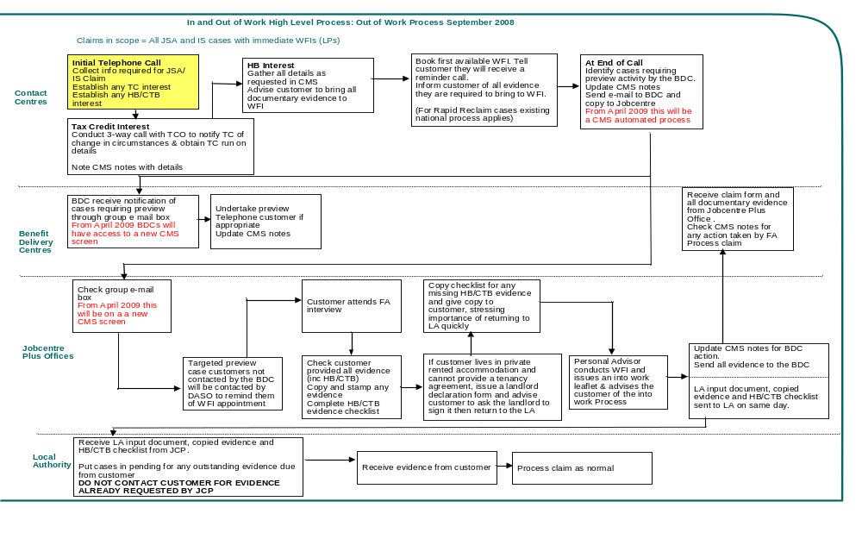
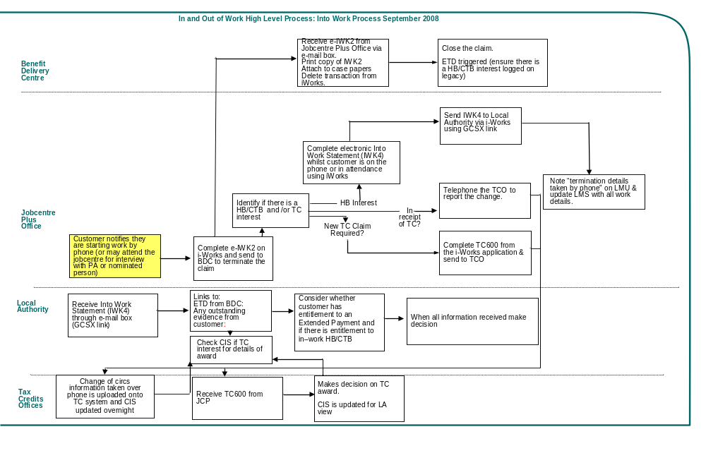

Housing and Council Tax Benefit checklist

For Official Use
Date of Claim | Completed by:  Date of issue:
Customer Name
Address

Documents Received. Originals copied, copies stamped and signed. |  | Type of Evidence | Documents not provided and requested by DWP
Customer | Partner |  | Customer | Partner
 |  | Identity
 |  | Proof of Partner Identity (if customer working or claiming contributions based JSA)
 |  | Income and savings
 |  | Proof of wages (5 weekly or 2 monthly payslips)
 |  | Proof of Bank/Building Society accounts (Last 2 full months)
 |  | Proof of other investments (e.g. shares, ISA, premium bonds)
 |  | Other Income (Please state)
 |  | Other (Please state)
 |  | Private tenant customers
 |  | Tenancy Agreement, Rent Book
 |  | Landlord Declaration Letter confirming tenancy
 |  | Proof of rent paid (e.g. rent book, rent receipts)
 |  | Non-dependants
 |  | Proof of non-dependant income

PLEASE NOTE: All evidence for Housing and Council Tax Benefit must be sent direct to the Local Authority Housing Benefit Office.
Please send the information as quickly as possible so that your claim for Housing and Council Tax Benefit can be assessed quickly.
If you do not supply this information within ONE MONTH from the date this form was given to you (see date of issue above) it will be assumed that you are not entitled to Housing and Council Tax Benefit.
Landlord’s Declaration Form
Only your landlord or their agent must fill in this section.

Please return the completed form direct to your local authority.

Full name and address of tenant
Name
Address and
postcode
Phone number
Is the person above a joint tenant? Yes/No

If yes, please give below the name(s) of the other tenants
Joint Tenants
Your full name and address (or your agent’s details)
Name
Address and postcode
Phone number
Do you own the property the tenant is living in? Yes/No

If “No”, please give below the full name and address of the person who does
Name
Address and postcode
Phone number

Details of occupancy and rent
How much rent do you charge? | £
How often does the tenant pay? (eg every week)
When did the tenant move in?
When did you start charging the tenant rent?
What was the date of the last increase in rent?
What is the date of the next increase in rent?
Is the tenant in arrears with the rent and if so by how many weeks?

Details of occupancy and rent charged
We need to know if the rent includes payments for any of the following, if so please state the amount charged.
Council Tax Heating Emergency alarm
£
£
£

Lighting Laundry General Counselling and support
£
£
£

Gardening Meals Cleaning rooms and/or windows
£
£
£

Garage Hot water Any other services
£
£
£

Water rates Fuel for
£
£
Cooking

If you have included an amount for meals please tick which meal is included
Breakfast Lunch Evening Meal

We need to know which rooms your tenant uses solely/shares with other people, and the total number of rooms in the property
Rooms | Number of rooms in  the whole property | Number of rooms that  only the tenant uses | Number of rooms that  tenant shares with other people
Living rooms
Bedrooms
Bed-sitting rooms
Kitchens
Bathrooms
Separate toilet
Other
Is the property
Furnished? |  | Partly furnished? |  | Unfurnished?
Are you related to the tenant or any member of the household?
Yes |  | No
If “yes” what is the relationship (for example father, mother, son, daughter)

Declaration: Please read and sign the declaration
- I confirm that the information I have given is correct and complete.
- I understand I may be prosecuted if I give incorrect or incomplete information.
- I agree you can check the information I have given on this form.

Name
Signature
Date

Starting Work | For Working Tax Credit we will ask you:  - Your total household income for this tax year and the previous one, including all taxable Social Security benefits and partner’s earnings  - Whether you are in receipt of Child Tax Credit  - Details of any children you have  - Your employer’s Pay As You Earn (PAYE) tax reference number (or your own reference number if you will be self-employed)  - Whether you or a child are in receipt of the Highest Rate Care Component of Disability Living Allowance or Higher rate of Attendance Allowance  - Bank/building society account details for you and your partner and evidence to support any savings and investments you may have - for example share certificates, ISAs  - Appointee details (If you want someone to act on your behalf regarding your benefits application, please provide their personal details)  - The name and address of your childcare provider  - The name of the local authority or other body (for example OFSTED) that registered or approved your child care provider  - The registration number of the body that registered or approved your childcare provider  - The amount of child care you pay each week  

To help us to help you get the benefits you are entitled to when you or your partner start work please ring us on ……………………………
We can close your/your partner’s Jobseeker’s Allowance (JSA)/Income Support (IS) claim AND help you to claim in-work benefits, that is, Housing and Council Tax Benefit and Working Tax Credit.

When you ring us we will ask you about any changes to your circumstances or any work you have done since your last declaration and for information depending on which in-work benefits you may like to claim.

We need to know:
- Your/your partner’s full name and address
- Your/your partner’s National Insurance number
- Your/your partner’s date of birth
- The date you/your partner are starting work
- Your/your partner’s employer’s name, address and telephone number
- The number of hours you/your partner will be working

Any information that you supply may be provided to the Local Authority or Her Majesty’s Revenue and Customs.
For Housing Benefit/Council Tax Benefit we will ask you if you have:
- The reference number for any Housing Benefit/Council Tax Benefit you were claiming while out of work
- Bank/building society statements for the last 2 full months for all your accounts (even if they are empty or overdrawn) and evidence to support any savings and investments you may have - for example share certificates, ISA’s.
- Child Benefit payments
- Other Social Security benefits
- Other income
- Childcare costs you pay to a registered provider

We will tell you more about the information you will need to provide for the local authority when you telephone us.

FORM IWK4
Into Work Statement
The customer has consented to their details being shared
Part 1 - Personal Details
Field | Data
NI Number
Surname
Forename
Date of Birth
Partner NI Number
Partner Surname
Partner Forename
Partner Date of Birth
Address
Post Code
Telephone
Local Authority
Part 2 - Employment Details
Field | Data
Who is Starting Work
Date Starting Work
Job Title
Employer Name
Employer Address
Employer Post Code
Employer Telephone
Hours Per Week
Estimated Annual Gross Earnings
Payment Period
Duration >= 5 Weeks
Part 3 - Benefits and Credit Details
Field | Data
Date Last Claimed Benefit
Worked Since Last Declaration
Change in Circumstances Affecting JSA, IS, HB, or CTB
Details of Change in Circumstances
Currently Receiving HB/CTB
Wishes to Continue Claiming HB/CTB
Housing Benefit/Council Tax Benefit Reference
Bank Accounts or Investments Held
Currently Receiving Child Benefit
Currently Receiving Any Other Benefits
Any Other Income (Including Earnings)
Details of Other Income
Paying for Registered Child Care
Wishes to Claim WTC
Already Receiving CTC
Part 4 - Action Taken
Field | Data
IWK1 Completed
TC600 Completed
Evidence Requested
JCP Contact Details
Name
Telephone

Allocation of the additional £3m administration subsidy to support implementation

Local Authority | Funding Allocation
Aberdeen | £8,785
Aberdeenshire | £6,753
Adur | £4,000
Allerdale | £4,053
Amber Valley | £4,545
Angus | £4,594
Argyll and Bute | £4,104
Arun | £5,934
Ashfield | £4,972
Ashford | £4,000
Aylesbury Vale | £4,675
Babergh | £4,000
Barking | £12,033
Barnet | £17,250
Barnsley | £11,627
Barrow in Furness | £4,000
Basildon | £8,937
Basingstoke and Deane | £4,797
Bassetlaw | £4,258
Bath and N E Somerset | £6,093
Bedford | £6,737
Bexley | £9,422
Birmingham | £71,465
Blaby | £4,000
Blackburn with Darwen | £8,671
Blackpool | £11,319
Blaenau Gwent | £4,000
Bolsover | £4,000
Bolton | £14,630
Boston | £4,000
Bournemouth | £9,531
Bracknell Forest | £4,000
Bradford | £29,049
Braintree | £5,205
Breckland | £4,863
Brent | £21,779
Brentwood | £4,000
Bridgend | £6,735
Brighton and Hove | £17,547
Bristol | £22,789
Broadland | £4,000
Bromley | £12,059
Bromsgrove | £4,000
Broxbourne | £4,000
Broxtowe | £4,000
Burnley | £5,764
Bury | £8,247
Caerphilly | £8,770
Calderdale | £10,514
Cambridge | £4,030
Camden | £18,371
Cannock Chase | £4,000
Canterbury | £5,118
Cardiff | £16,689
Carlisle | £4,069
Carmarthenshire | £7,980
Castle Point | £4,000
Central Bedfordshire 2009 | £7,765
Ceredigion | £4,000
Charnwood | £4,063
Chelmsford | £4,859
Cheltenham | £4,126
Cherwell | £4,159
Cheshire East 2009 | £12,125
Chesterfield | £5,137
Chichester | £4,000
Chiltern | £4,000
Chorley | £4,000
Christchurch | £4,000
City of London | £4,000
Clackmannanshire | £4,000
Colchester | £5,926
Conwy | £4,835
Copeland | £4,000
Corby | £4,000
Cornwall 2009 | £25,736
Cotswold | £4,000
Coventry | £19,946
Craven | £4,000
Crawley | £4,308
Croydon | £19,127
Dacorum | £4,595
Darlington | £5,159
Dartford | £4,000
Daventry | £4,000
Denbighshire | £4,326
Derby | £11,683
Derbyshire Dales | £4,000
Doncaster | £14,871
Dover | £4,996
Dudley | £14,400
Dumfries and Galloway | £8,038
Dundee | £10,630
Durham 2009 | £29,128
Ealing | £18,276
East Ayrshire | £7,322
East Cambridgeshire | £4,000
East Devon | £4,000
East Dorset | £4,000
East Dunbartonshire | £4,000
East Hampshire | £4,000
East Hertfordshire | £4,000
East Lindsey | £7,103
East Lothian | £4,000
East Northamptonshire | £4,000
East Renfrewshire | £4,000
East Riding of Yorkshire | £11,532
East Staffordshire | £4,000
Eastbourne | £5,406
Eastleigh | £4,000
Eden | £4,000
Edinburgh | £23,944
Elmbridge | £4,000
Enfield | £19,506
Epping Forest | £4,000
Epsom and Ewell | £4,000
Erewash | £4,365
Exeter | £4,581
Falkirk | £7,292
Fareham | £4,000
Fenland | £4,260
Fife | £19,091
Flintshire | £5,310
Forest Heath | £4,000
Forest of Dean | £4,000
Fylde | £4,000
Gateshead | £11,894
Gedling | £4,000
Glasgow | £58,754
Gloucester | £5,063
Gosport | £4,000
Gravesham | £4,000
Great Yarmouth | £6,005
Greenwich | £18,844
Guildford | £4,000
Gwynedd | £4,869
Hackney | £25,398
Halton | £7,449
Hambleton | £4,000
Hammersmith and Fulham | £13,661
Harborough | £4,000
Haringey | £20,692
Harlow | £4,259
Harrogate | £4,000
Harrow | £11,166
Hart | £4,000
Hartlepool | £6,799
Hastings | £6,484
Havant | £4,820
Havering | £8,874
Herefordshire | £6,805
Hertsmere | £4,000
High Peak | £4,000
Highland | £9,285
Hillingdon | £12,717
Hinckley and Bosworth | £4,000
Horsham | £4,000
Hounslow | £12,555
Huntingdonshire | £4,579
Hyndburn | £4,612
Inverclyde | £5,668
Ipswich | £6,531
Isle of Anglesey | £4,000
Isle of Wight | £7,683
Isles of Scilly | £4,000
Islington | £19,787
Kensington and Chelsea | £11,105
Kettering | £4,000
Kings Lynn and West Norfolk | £6,179
Kingston upon Hull | £18,107
Kingston upon Thames | £5,438
Kirklees | £18,812
Knowsley | £11,931
Lancaster | £5,712
Leeds | £35,651
Leicester | £19,553
Lewes | £4,000
Lewisham | £23,894
Lichfield | £4,000
Lincoln | £4,519
Luton | £9,427
Maidstone | £4,775
Maldon | £4,000
Malvern Hills | £4,000
Manchester | £37,172
Mansfield | £4,927
Medway | £12,028
Melton | £4,000
Mendip | £4,000
Merton | £8,218
Mid Devon | £4,000
Mid Suffolk | £4,000
Mid Sussex | £4,000
Middlesbrough | £10,670
Midlothian | £4,000
Milton Keynes | £10,204
Mole Valley | £4,000
Monmouthshire | £4,000
Moray | £4,000
Neath and Port Talbot | £7,727
New Forest | £5,135
Newark and Sherwood | £4,000
Newcastle under Lyme | £4,942
Newcastle upon Tyne | £16,594
Newham | £27,989
Newport | £6,584
North Ayrshire | £8,639
North Devon | £4,264
North Dorset | £4,000
North East Derby | £4,000
North East Lincoln | £9,790
North Hertfordshire | £4,319
North Kesteven | £4,000
North Lanarkshire | £20,387
North Lincolnshire | £7,274
North Norfolk | £4,192
North Somerset | £8,767
North Tyneside | £10,414
North Warwickshire | £4,000
North West Leicester | £4,000
Northampton | £8,659
Northumberland 2009 | £13,641
Norwich | £7,964
Nottingham | £19,246
Nuneaton and Bedworth | £5,212
Oadby and Wigston | £4,000
Oldham | £12,094
Orkney | £4,000
Oxford | £5,667
Pembrokeshire | £4,628
Pendle | £4,861
Perth and Kinross | £5,167
Peterborough | £9,530
Plymouth | £12,870
Poole | £5,231
Portsmouth | £11,924
Powys | £4,236
Preston | £6,674
Purbeck | £4,000
Reading | £6,863
Redbridge | £11,551
Redcar and Cleveland | £8,387
Redditch | £4,000
Reigate and Banstead | £4,000
Renfrewshire | £10,402
Rhondda Cynon Taff | £12,781
Ribble Valley | £4,000
Richmond upon Thames | £6,235
Richmondshire | £4,000
Rochdale | £12,436
Rochford | £4,000
Rossendale | £4,000
Rother | £4,000
Rotherham | £12,080
Rugby | £4,000
Runnymede | £4,000
Rushcliffe | £4,000
Rushmoor | £4,000
Rutland | £4,000
Ryedale | £4,000
Salford | £14,737
Sandwell | £19,918
Scarborough | £6,092
Scottish Borders | £4,948
Sefton | £15,660
Selby | £4,000
Sevenoaks | £4,000
Sheffield | £27,458
Shepway | £4,846
Shetland | £4,000
Shropshire 2009 | £10,605
Slough | £6,779
Solihull | £7,212
South Ayrshire | £5,672
South Bucks | £4,000
South Cambridgeshire | £4,000
South Derbyshire | £4,000
South Gloucestershire | £7,685
South Hams | £4,000
South Holland | £4,000
South Kesteven | £4,000
South Lakeland | £4,000
South Lanarkshire | £17,138
South Norfolk | £4,000
South Northamptonshire | £4,000
South Oxfordshire | £4,000
South Ribble | £4,000
South Somerset | £5,601
South Staffordshire | £4,000
South Tyneside | £9,734
Southampton | £12,026
Southend on Sea | £9,657
Southwark | £24,347
Spelthorne | £4,000
St Albans | £4,000
St Edmundsbury | £4,000
St Helens | £10,841
Stafford | £4,000
Staffordshire Moorlands | £4,000
Stevenage | £4,000
Stirling | £4,000
Stockport | £11,147
Stockton on Tees | £9,135
Stoke on Trent | £14,418
Stratford on Avon | £4,000
Stroud | £4,000
Suffolk Coastal | £4,000
Sunderland | £20,314
Surrey Heath | £4,000
Sutton | £7,349
Swale | £6,279
Swansea | £11,957
Swindon | £7,331
Tameside | £13,493
Tamworth | £4,000
Tandridge | £4,000
Taunton Deane | £4,000
Teignbridge | £4,761
Telford and Wrekin | £8,268
Tendring | £8,132
Test Valley | £4,000
Tewkesbury | £4,000
Thanet | £9,294
Three Rivers | £4,000
Thurrock | £6,648
Tonbridge and Malling | £4,000
Torbay | £8,674
Torfaen | £4,258
Torridge | £4,000
Tower Hamlets | £26,096
Trafford | £9,250
Tunbridge Wells | £4,000
Uttlesford | £4,000
Vale of Glamorgan | £4,653
Vale of White Horse | £4,000
Wakefield | £17,067
Walsall | £17,499
Waltham Forest | £15,853
Wandsworth | £16,664
Warrington | £6,986
Warwick | £4,000
Watford | £4,000
Waveney | £6,098
Waverley | £4,000
Wealden | £4,000
Wellingborough | £4,000
Welwyn Hatfield | £4,000
West Berkshire | £4,231
West Cheshire & Chester 2009 | £12,661
West Devon | £4,000
West Dorset | £4,000
West Dunbartonshire | £7,112
West Lancashire | £4,298
West Lindsey | £4,000
West Oxfordshire | £4,000
Western Isles | £4,000
Westminster | £16,386
Weymouth and Portland | £4,000
Wigan | £15,663
Wiltshire 2009 | £14,580
Winchester | £4,000
Windsor and Maidenhead | £4,000
Wirral | £19,733
Woking | £4,000
Wokingham | £4,000
Wolverhampton | £16,361
Worcester | £4,000
Worthing | £4,074
Wrexham | £5,255
Wychavon | £4,000
Wycombe | £4,747
Wyre | £4,466
Wyre Forest | £4,405
York | £5,828
 | £3,000,000

